
بسم الله الرحمن الرحيم

Imam Mohammad Bin Saud Islamic University
College of Computer & Information Science
Summer 2011
(421Management Information Systems)

Time Allowed:60 Minutes 20 Marks

Student name:---------------------------------------------------------------------

Chose the best answer:
1) An example of a social complementary asset is
A) technology and service firms in adjacent markets. B) training programs. C) distributed decision-making rights. D) all of the above.
2) Disciplines that contribute to the technical approach to information systems are:
A) computer science, engineering, and networking. B) operations research, management science, and computer science. C) engineering, utilization management, and computer science.
D) management science, computer science, and engineering.
3) Psychologists study information systems with an eye to understanding
A) how systems affect individuals, groups, and organizations. B) how human decision makers perceive and use formal information. C) how new information systems change the control and cost structures within the firm. D) the production of digital goods.
4) Which field of study focuses on both a behavioral and technical understanding of information systems? A) sociology B) operations research C) economics D) management information systems
5) Which systems are typically a major source of data for other systems?
A) transaction processing systems B) management information systems
C) executive support systems D) decision-support systems
6) The term "management information systems" designates a specific category of information systems serving:
A) integrated data processing throughout the firm. B) transaction process reporting.
C) employees with online access to historical records. D) middle management functions.
7) Which type of system would you use to forecast the return on investment if you used new suppliers with better delivery track records?
A) ESS B) TPS C) MIS D) DSS
8) Decision-support systems are often referred to as business ________ systems.
A) information B) intelligence C) analysis D) modeling
9) Executive support systems (ESS )are specifically designed to serve which level of the organization?
A) operational B) end-user C) middle management D) senior management
10) What is the most important function of an enterprise application?
A) increasing speed of communicating
B) enabling business functions and departments to share information
C) enabling a company to work collaboratively with customers and suppliers
D) enabling cost-effective e-business processes
11) A(n) ________ system collects data from various key business processes and stores the data in a single, comprehensive data repository, usable by other parts of the business.
A) transaction B) enterprise C) automatic reporting D) management information
12) You manage the IT department at a small startup Internet advertiser. You need to set up an inexpensive system that allows customers to see real-time statistics such as views and click-throughs about their current banner ads. Which type of system will most efficiently provide a solution?
A) CRM B) enterprise system C) extranet D) intranet
13) Enterprise systems are also known as ________ systems.
A) resource planning B) enterprise resource planning C) enterprise support
D) management information
14) ________ systems integrate supplier, manufacturer, distributor, and customer logistics processes.
A) Collaborative distribution B) Supply-chain management
C) Reverse logistics D) Enterprise planning
15) E-government refers to the application of ________ to digitally enable government and public sector agencies' relationships with citizens, businesses, and other arms of government.
A) the Internet and networking technologies B) e-commerce
C) e-business D) any computerized technology
23) Buying or selling goods over the Internet is called
A) e-commerce. B) e-business. C) an intranet. D) an extranet.
16) A ________ is a senior manager who oversees the use of IT in the firm.
A) CEO B) CFO C) CIO D) CTO

17) Which of the following types of organizing the information systems function would you be most likely to find in a small company with 20 employees?
A) as departments within each functional area B) as a separate, centralized department
C) represented within each major division of the company D) none of the above
18) You have been hired by a non-profit agency to implement a system to handle their donations. Event fundraisers need to be able to quickly access a donor's information and history. The marketing department needs to be able to create customized mailing lists, in order to send different messages to different types of donors. What system will best meet these needs?
A) TPS B) TPS with DSS capabilities C) TPS with MIS capabilities
D) TPS with ESS capabilities
19) A(n) ________ is a set of logically related activities for accomplishing a specific business result.
A) business process B)MIS C) Tasks D)All answers in correct
20) A Web interface used to present integrated personalized business content to users is called a(n) ________.
A) portal B) IT applications C)Xmal D) Unix
21) ________ applications span the entire firm, integrating information from multiple functions and business processes to enhance the performance of the organization as a whole.
A): Enterprise B) business process C) Web applications D)All answers are correct
22) An organization is a
A) stable, formal social structure that takes resources from the environment and processes them to produce outputs. B) formal, legal entity with internal rules and procedures that must abide by laws. C) collection of social elements. D) b and c E) a, b, and c
23) According to agency theory, the firm is viewed as a(n):
A) unified, profit-maximizing entity. B) task force organization that must respond to rapidly changing environments. C) entrepreneurial endeavor.
D) "nexus of contracts" among self-interested individuals.
24) The ________ model is used to describe the interaction of external forces that affect an organization's strategy and ability to compete.
A) network economics B) competitive forces C) competitive advantage D) demand control
25) A firm can exercise greater control over its suppliers by having
A) more suppliers. B) fewer suppliers. C) global suppliers. D) local suppliers.
26) Amazon's use of the Internet as a platform to sell books illustrates a tactical use of information services for
A) low-cost leadership; product differentiation; focus on market niche; and customer and supplier intimacy. B) product differentiation. C) focusing on market niche.
D) strengthening customer intimacy.
27) When a firm provides a specialized product or service for a narrow target market better than competitors, they are using a ________ strategy.
A) product differentiation B) market niche C) mass customization D) process efficiency
28) The Internet raises the bargaining power of customers by
A) creating new opportunities for building loyal customer bases.
B) making more products available.
C) making information available to everyone.
D) lowering transaction costs.
29) The value chain model
A) categorizes five related advantages for adding value to a firm's products or services.
B) sees the supply chain as the primary activity for adding value.
C) categorizes four basic strategies a firm can use to enhance its value chain.
D) helps a firm identify points at which information technology can most effectively enhance its competitive position.
30) Benchmarking:
A) compares the efficiency and effectiveness of your business processes against strict standards.
B) allows industry participants to influence industry-wide standards.
C) is used to measure the speed and responsiveness of information technology.
D) Synchronizes the business processes of customers, suppliers, and trading partners.
48) The most successful solutions or methods for achieving a business objective are called
A) Value activities. B) Best processes. C) Core competencies. D) Best practices.
31) An example of synergy in business is
A) Amazon's use of the Internet to sell books.
B) Alsobai,Almagran, merger with AlBald Bank One Corporation, which provided Bank servces with a network of Bank branches in SA regions.
C) Blockbuster combining traditional video rental with online video rental.
D) Wal-Mart's order entry and inventory management system to coordinate with suppliers.
32) An information system can enhance core competencies by
A) Providing better reporting facilities.
B) Creating educational opportunities for management.
C) Allowing operational employees to interact with management.
D) Encouraging the sharing of knowledge across business units.
33) A virtual company
A) Uses the capabilities of other companies without being physically tied to those companies.
B) uses Internet technology to maintain a virtual storefront.
C) uses Internet technology to maintain a networked community of users.
D) provides entirely Internet-driven services, or virtual products.
34) Which type of infrastructure services provides voice and video connectivity to employees, customers, and suppliers?
A) Networking B) telephone C) VOIP D) telecommunications
35) A client computer networked to a server computer, with processing split between the two types of machines, is called a(n):
A) service-oriented architecture. B) on-demand architecture.
C) multi-tiered client/server architecture. D) two-tiered client/server architecture.
36) Which of the following factors provides an understanding of why computing resources today are ever more available than in previous decades?
A) Network economics B) law of mass digital storage and Moore's law
C) Declining communications costs, universal standards, and the Internet
D) all of the above
37) The multitasking, multi-user, operating system developed by Bell Laboratories that operates on a wide variety of computing platforms is
A) Unix. B) Linux. C) OS X. D) COBOL.
38) Connecting geographically remote computers in a single network to create a "virtual supercomputer" is called
A) co-location. B) edge computing.
C) grid computing. D) Utility computing.
39) The process of presenting a set of computing resources (such as computing power or data storage) so that they can all be accessed in ways that are not restricted by physical configuration or geographic location is called
A) cloud computing. B) Autonomic computing. C) Virtualization.
D) multicore processing.
40) What is the foundation technology for Web services?
A) XML B) HTML C) SOAP D) UDDI
41) The term business ecosystem describes---------
A) the interplay between the various organizational
B) Industry sets of firms providing related services and products
C) a disruptive technology D) all of the above

Companies implementing Enterprise Software would have to do several steps before starting use it. What are these steps? (4 pts )
- --------------------------------------------------------------------------------------------------------------------------
- --------------------------------------------------------------------------------------------------------------------------
- ----------------------------------------------------------------
- -----------------------------------------------------------------------------------------------------------
There are three types of Information Systems Department of the large firms

Put the name of each one in front of its picture

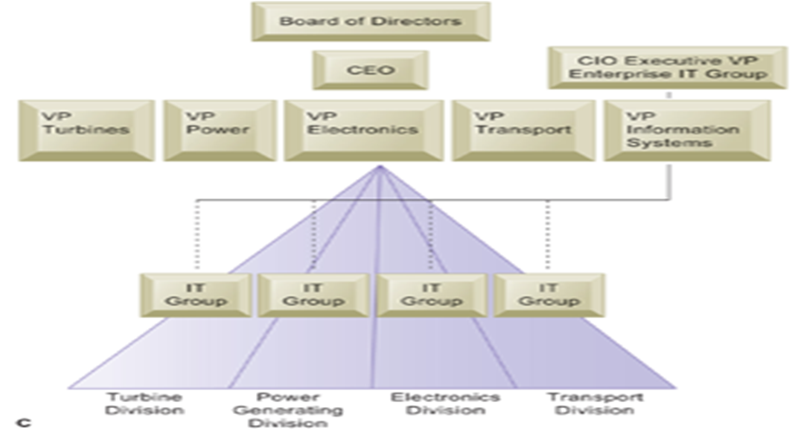

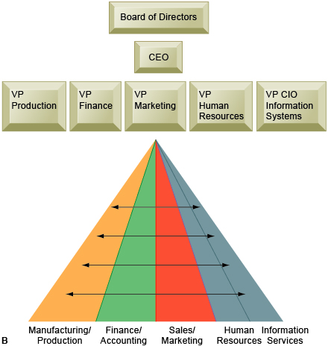

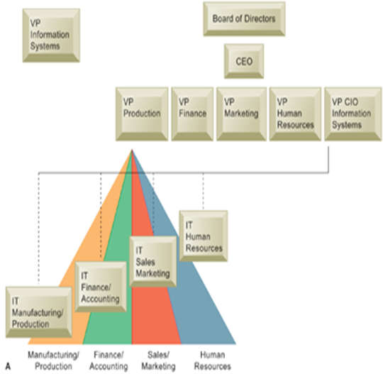

With my best regards
DR:Saleh Al_zahrani

