What are Data Flow Diagrams?
Data flow diagrams illustrate how data is processed by a system in terms of inputs and outputs.
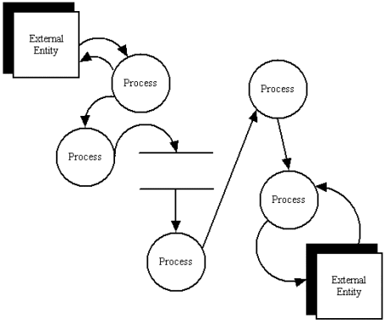
A data flow diagram
Data Flow Diagram Notations
You can use two different types of notations on your data flow diagrams: Yourdon & Coad or Gane & Sarson.
Process Notations  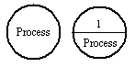  Yourdon and Coad  Process Notations  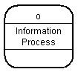  Gane and Sarson  Process Notation |  | Process  A process transforms incoming data flow into outgoing data flow.  Learn how to edit text on this object.
Datastore Notations  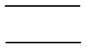  Yourdon and Coad  Datastore Notation  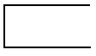  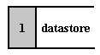  Gane and Sarson  Datastore Notations |  | DataStore  Datastores are repositories of data in the system. They are sometimes also referred to as files.  Learn how to edit text on this object.
Dataflow Notations  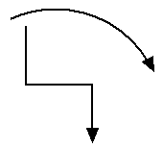 |  | Dataflow  Dataflows are pipelines through which packets of information flow. Label the arrows with the name of the data that moves through it.  Learn how to connect objects.
External Entity Notations  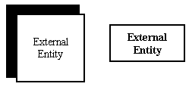 |  | External Entity  External entities are objects outside the system, with which the system communicates. External entities are sources and destinations of the system's inputs and outputs.  Learn how to edit text on this object.

Data Flow Diagram Layers
Draw data flow diagrams in several nested layers. A single process node on a high level diagram can be expanded to show a more detailed data flow diagram. Draw the context diagram first, followed by various layers of data flow diagrams.
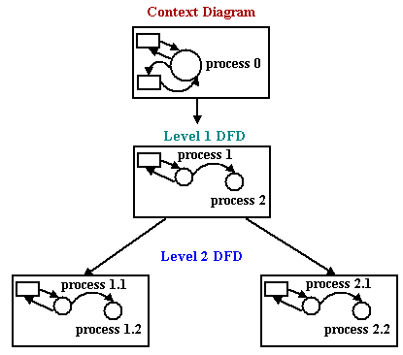
The nesting of data flow layers
Context Diagrams
A context diagram is a top level (also known as Level 0) data flow diagram. It only contains one process node (process 0) that generalizes the function of the entire system in relationship to external entities.
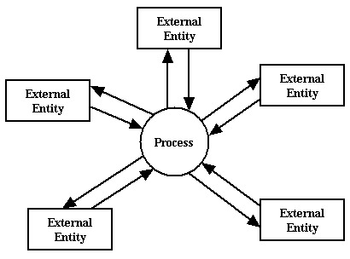
DFD levels
The first level DFD shows the main processes within the system. Each of these processes can be broken into further processes until you reach pseudocode.
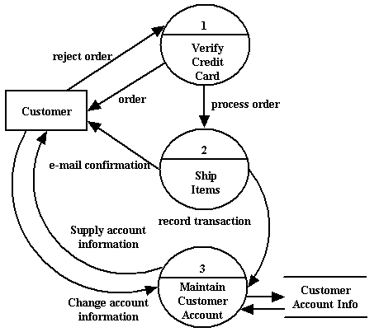
An example first-level data flow diagram

